**CASE STUDY: 02**

**Deploy any Spring Boot REST API CRUD in Docker Container**

* **Create and Run Spring Boot Project.**

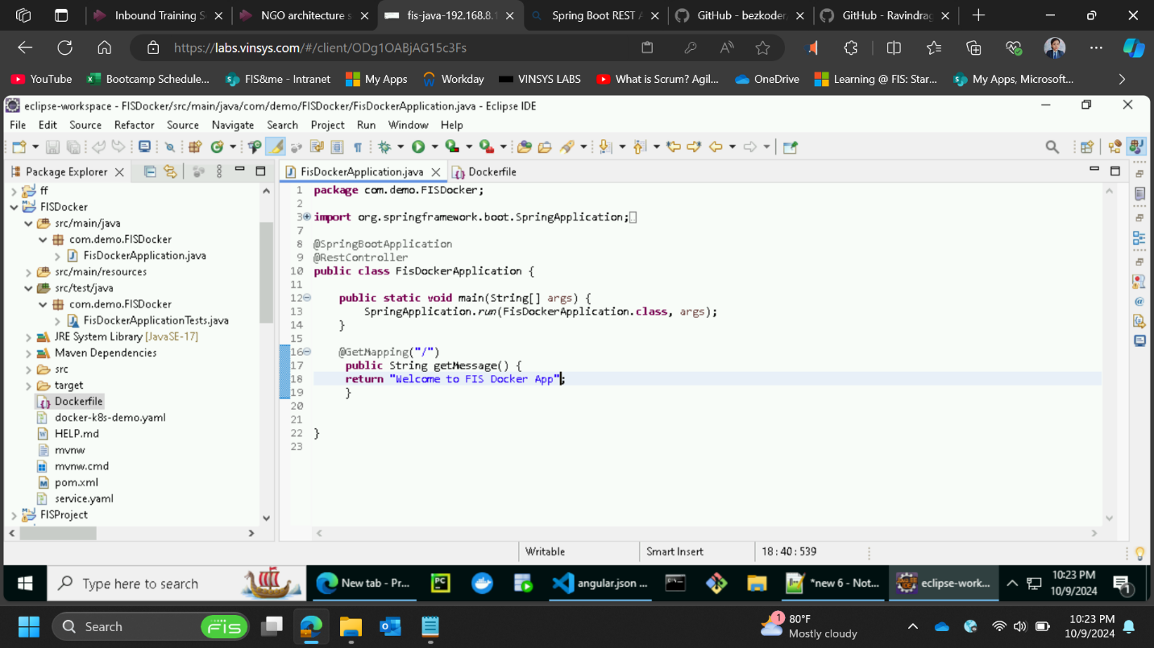

* **application.properties file:**

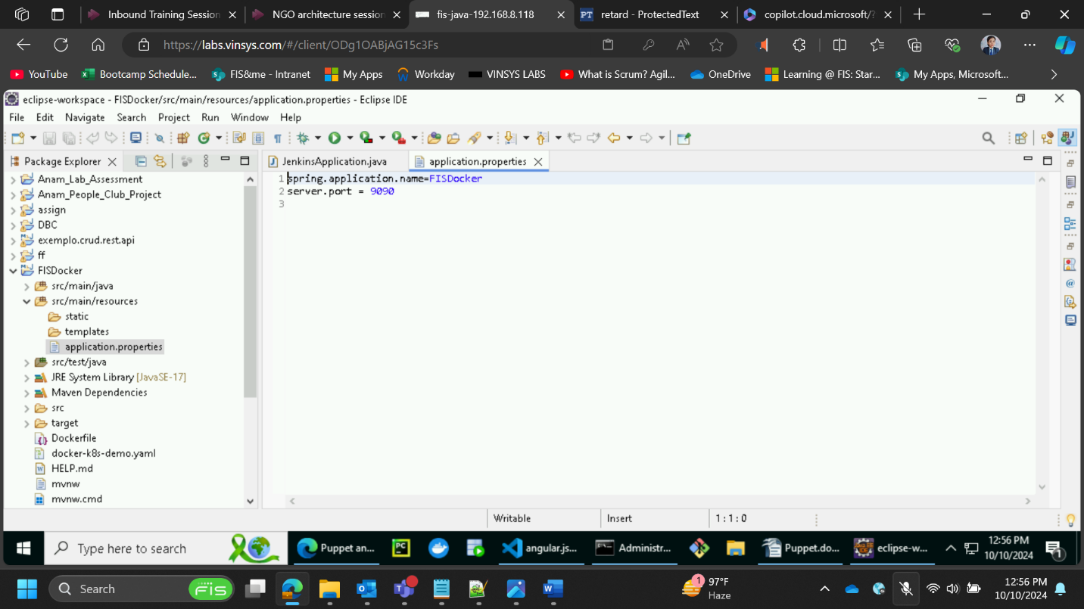

* **Build a docker image:**

* **Verify that the docker image has been built successfully:**

* **Run the docker image:**

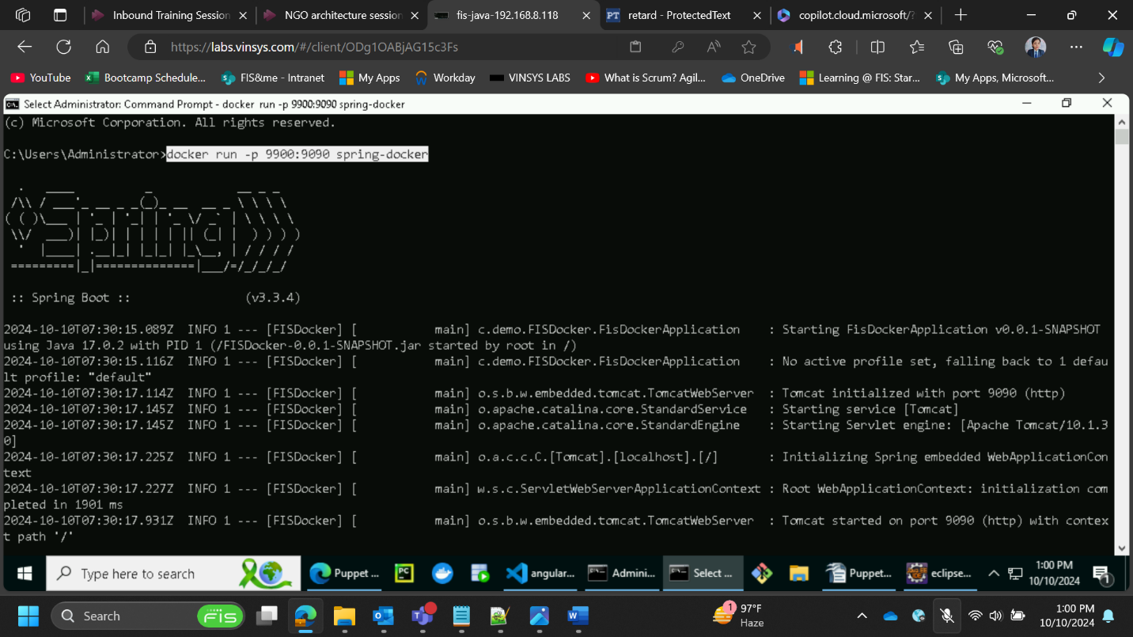

* **Run the springboot app on Docker port specified:**

